**Assignment 1**

Name: Miss. Rashmi Jaykumar Mane

College Name: NKOCET Solapur.

Roll No.: B-78

**Attempt all questions, each question carries 5 marks, there is no negative marking.  
Upload your answer file with your name in repository “/Assignment1” location.**

**Q.1) How user can push files on GitHub?**

1. Open Git Bash.
2. Change the current working directory to your local repository.
3. Stage the file for commit to your local repository.

**Git add .**

1. Commit the file that you've staged in your local repository.

**$ git commit -m "Add existing file"**

1. Push the changes in your local repository to GitHub.

**$ git push origin your-branch**

**Q.2) Which command are used to check GIT Version?**

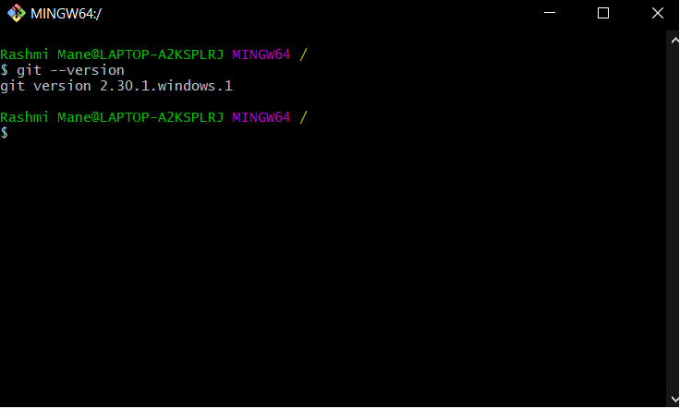

**Q.3) How you can collaborate with others in Github?**

Create a new repository on GitHub.

Go to Github and click the ‘+’ button in the repo right corner and select ‘New Repository’.

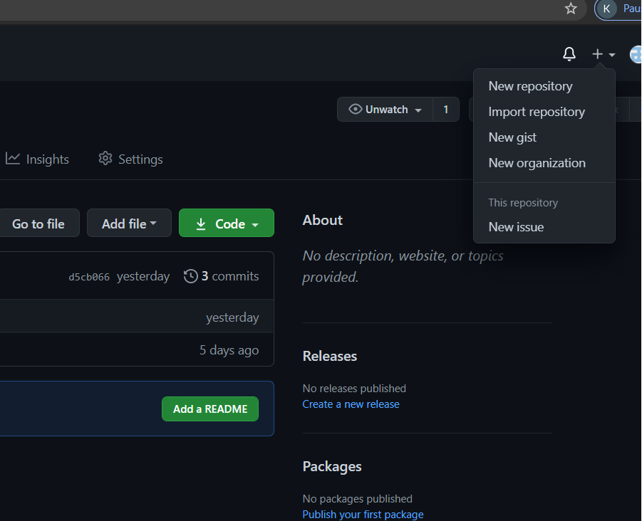

Setup page: instructions for connecting the Repo you just created in Github (Remote) to the directory you created in your terminal (Local).

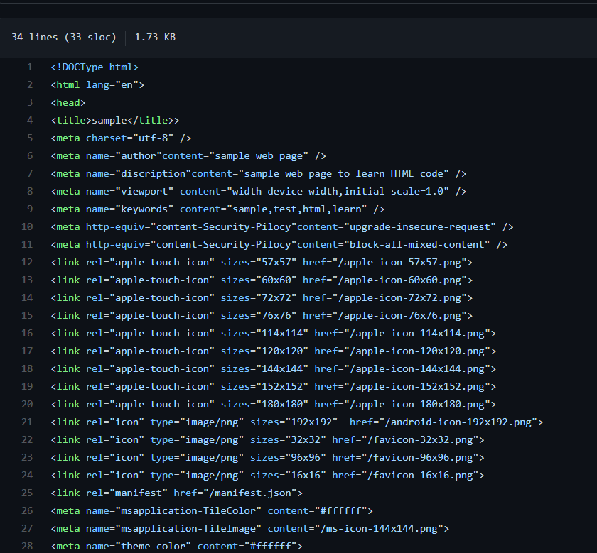

And if you go to your Github Repo page, you’ll see the ReadMe that you intialized with and the reference to the first commit you made.

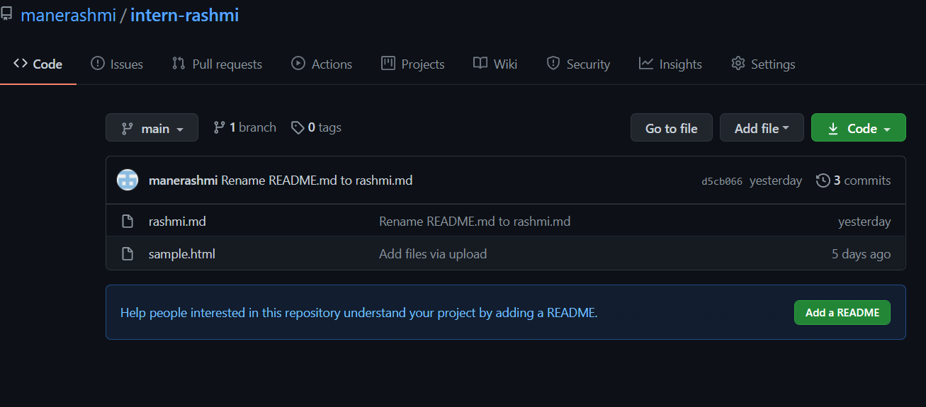

Now let’s get this Repo up to date. Go back to your terminal and git add, git commit, and git push:

**$ git add .**

**$ git commit -m "Second commit"**

**$ git push**

**Q.4) How you can push updates on your repository?**

**To push to a Git repository**

At the command line, make sure you've changed into the repository directory.

Enter git push at the command line to push your commits from your local repository to Bitbucket. To be specific about exactly where you're pushing, enter git push <remote_server> <branch_name>. This command specifies you're pushing to:

remote_server — the name of the remote server. In most cases, origin indicates that you're pushing to Bitbucket.

branch_name — the repository branch where you made your changes and want to push them. A branch allows you do work on a set of code for your repository separate from the main codebase.

If prompted for authentication, enter your Bitbucket username and password.  
In this example, origin is the remote server and master is the branch where you're pushing:

$ git push origin master   
Password:  
Counting objects: 6, done.  
Delta compression using up to 4 threads.  
Compressing objects: 100% (3/3), done.  
Writing objects: 100% (4/4), 23.98 KiB, done.  
Total 4 (delta 0), reused 0 (delta 0)  
remote: bb/acl: alui is allowed. accepted payload.  
To https://alui@staging.bitbucket.org/alui/alui-git-fork.git  
   0ad86b3..395d3c2  master -> master

Open your Bitbucket repository in your browser. The **Commits** tab shows your most recent commits.

**Q.5) What is alternative of Github & what is Full form of GIT?**

### GitLab

### BitBucket

### Launchpad

Full form of GIT

Gastrointestinal Tract Miscellaneous Food & Nutrition